Universal Library Offer Virtual Seminar Programme

10.00 Introduction from Carol Stump, Libraries Connected President, Mark Freeman, Past President & Ayub Khan, President Elect.
10.20 Reading Update, from offer lead Catherine Mann
10.35 Ireland Reads - Stuart Hamilton, Head of Libraries Development for the Local Government Management Agency (LGMA) in Ireland.
11.10 Reading Related Flash Films
11.20 – 11.35 Break
11.35 Children’s Promise Update, from Chris Myhill, ASCEL Chair
11.45 Health and Wellbeing Update, from offer leads Sue Ball & Debbie Hicks
12.00 Children’s Mental health and how libraries can support - Dr Clare Etherington
12.35 Health & Wellbeing Flash Films
12.45 – 14.00 Lunch Break
14.00 Vision and Print Impaired People’s Promise update, from Mark McCree, Share the Vision Chair
14.10 Information and Digital Update, from offer lead Dave Lloyd
14.25 Addressing the Digital Divide and Tackle Digital Exclusion - APLE Collective
15.00 Information & Digital Flash Films
15.10 – 15.25 Break
15.25 Culture and Creativity Update, from offer lead Liz McMillan
15.40 Getting Artists and Performers Back Into Libraries - Sam Steer, INN CROWD with performance by poet Luke Wright.
16.15 Culture & Creativity Flash Films
16.25 Closing Words from Isobel Hunter
16.30 Finish

Keynote Speakers
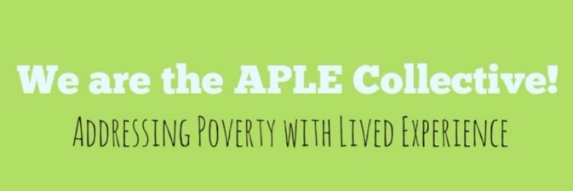
The APLE Collective is a national collective of individuals who experience poverty. Working together with organisations that support them to take positive action to eradicate poverty. APLE Collective campaign on the International Day for the Eradication of Poverty and to solve the Digital Divide. Winners of the UK Parliament Awards, Digital Campaign group of the year 2021, APLE Collective members have been campaigning to solve the digital divide, meeting with Metro Mayors, MPs, writing blogs and newspaper articles and are publishing a Policy Press Book about our work in June of this year. www.aplecollective.com

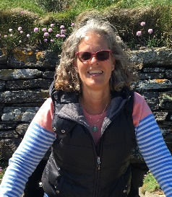
Dr Clare Etherington has been a GP in Harrow and Hillingdon for 35 years and a locum, salaried GP and partner over that time. She now has a portfolio career so, as well as seeing patients, she has other roles. She is Primary Care Dean for Health Education England, across North West London. She works with training hubs on the education and training of everyone in the primary care teams. She does education work for the Royal College of General Practitioners including being an examiner, writing e-learning and is an editor for the GP trainee Journal. She has had her nose in a book since she learned to read when she was two so working with the Reading Agency is a natural fit. She also does some work with the charity Best Beginnings.

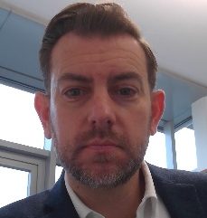
Stuart Hamilton is the Head of Libraries Development for the Local Government Management Agency (LGMA) in Ireland. He is the national advisor on libraries in the local government sector and leads the strategic development and implementation of service innovation and change management. He was previously Deputy Executive Director of International Relations and Communications at the Qatar National Library where he developed the library’s international relations, partnerships and outreach activities, and led the coordination of the library’s opening in 2017/2018.

Before moving to Qatar he was Deputy Secretary General at the International Federation of Library Associations and Institutions (IFLA) in the Netherlands where he directed IFLA’s policy and advocacy work around copyright, human rights, Internet governance, and all issues relating to access to information, libraries and the digital environment. He is the current President of the National Authorities on Public Libraries in Europe (NAPLE) Forum.

Sam Steer is the Project Manager for INN CROWD. INN CROWD is a unique arts project created by partners Creative Arts East, Applause Rural Touring and National Centre for Writing that specialises in commissioning and touring Live Literature work that is specifically suited to small, rural, unconventional spaces. Live Literature is an artform that INN CROWD is helping to support and develop. Covering all manner of literary performances from poetry shows, to storytelling, to spoken word performances. INN CROWD specifically commissions and supports content that is accessible and engaging for all adult audiences. The project consists of a network of rural touring companies across the country with wide reaching experience including within the library sector. INN CROWD also offers support to venues, from providing high quality bespoke marketing and social media support to on-call queries – they ensure that managing the lead-up to the event is an easy process, even for those who haven’t used their spaces for live work before.

Flash Films

These short 3 minute films will showcase projects that have been taking place in libraries across the UK linked to our Universal Library Offer themes, they will also be available on our website after the event.

Reading
- Reader Development in a Virtual World, West Sussex Libraries
- A Season of Reading, Staffordshire Libraries
- Word Online Project, Literature Works

Health & Wellbeing
- The Death Positive Library, Vision Redbridge Culture & Leisure
- Reading Friends, Norfolk Libraires
- Social Prescribing Toolkit, Conwy Libraries

Information & Digital
- Information Literacy, Tower Hamlets School Library Services
- Digital Buddies, North Yorkshire Libraries
- Tablet Provision, Newham

Culture & Creativity
- Arts Diamonds, Gateshead Libraries
- Culture Programme, Hull Libraries

