Expert Bank: Developing a communications and engagement plan for libraries
By Heidi Bellamy, Culture First with Worcestershire Libraries
April 2021

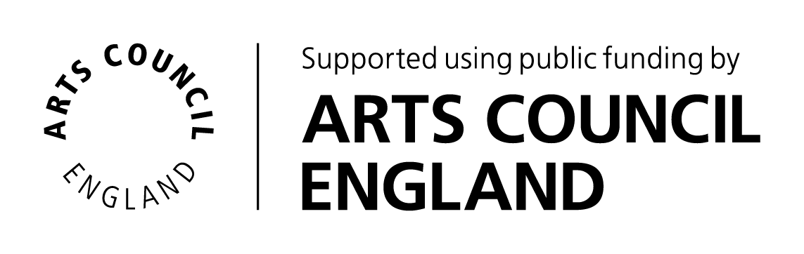

Contents

1. About this toolkit P3
2. Creating a strategic framework for communications P3
3. Audiences, channels and messages P4
4. Stakeholder engagement and building relationships P6
Appendix 1. Audiences/Stakeholders Segmentation P10
Appendix 2. Libraries communications and engagement plan template P13
Appendix 3. Stakeholder Mapping Exercise P27
Appendix 4. Suggested framework for meeting with internal service heads
and commissioners/potential external partners P32

About this toolkit
This toolkit is based on the work undertaken with Worcestershire Libraries as part of their transformation programme and is a result of the expert bank support offered by Libraries Connected.

Context for the support: The Worcestershire Library Strategy had been approved and a key workstream within the transformation programme was the creation of a Communication and Engagement Plan. The work on this element had not begun at the start of the support programme.

This toolkit can be used by any library service looking for guidance on developing a more strategic approach to communication and engagement. It provides an outline process, templates and tools for adaptation to the local context.

Creating a strategic framework for communications
It was agreed at an early stage that the format would be a plan that took a strategic approach to communication and engagement, rather than the creation of another entire strategy. This avoided replicating the work already undertaken to develop the library strategy, and meant the focus was more about setting out in detail how the library service would engage with communities around specific transformational activities and communicate the core library offer. By approaching this in a co-ordinated way, with objectives that could be measured in terms of outputs and outcomes, it would then act to frame the strategic messages while driving forward action.

If you intend embarking upon this journey in your locality, a good starting point is to look at the overarching council communication strategy. In this way you can use any existing templates for guidance that will help to ensure it ‘lands’ well with colleagues in the communications team. You can also replicate comms terminology, where appropriate, so that the plan resonates with the approach that senior managers and councillors or other decision makers are already familiar with.

The purpose of creating a framework at an early stage is to help capture existing information and provide a structure for generating new thinking. If you cannot identify a suitable format already available within your organisation, there is a sample template in Appendix 2 with content drawn from the Worcestershire Libraries Communication and Engagement Plan.

You may wish your plan to cover all elements of your Library Strategy; however in order to make it manageable, it may be more practical to focus on priority campaigns for the coming 12-18 months. Once your initial Communications and Engagement plan is complete, be sure to regularly review this working document as it will be an ongoing, iterative process with campaigns continuing to evolve.

Audiences, channels and messages
As part of the process you will need to consider the audiences you are hoping to communicate with, thinking about existing users, under-represented groups or non-users and how best to position the library service within the council and with partners.

Segmentation is really useful when you are thinking about communicating with audiences, particularly for change programmes (i.e. implementing Community Managed or Open Libraries); the more you know about users, the better your chances of successfully engaging with them. You can make sure, for example, that you tell them about some aspect that is likely to appeal to them, or that you use their favoured means of communication.

There are a number of different methodologies for identifying audiences. You may already have appropriate demographic data such as existing insights from your Libraries Needs Assessment. You may also have access to Acorn or Mosaic profiling to provide insight into the characteristics of the resident population in neighbourhoods. You can then cross reference whether the existing user profile matches that of the local population. There are alternative approaches to segmentation including Audience Spectrum, which segments the whole UK population by their attitudes towards culture, and by what they like to see and do. Appendix 1 contains more information on this topic.

Consideration will also need to be given to the communication and engagement channels available for you to use, how these can be mobilised to target the various audiences, which would work best in reaching vulnerable, isolated and under-represented groups. There is more information about the approach used in Worcestershire in Appendix 2.

Another element you will need to address is how to measure the reach and impact of specific approaches and targeted campaigns. Mindful of the capacity challenge, try to draw on readily available data supplemented by some simple additional collecting mechanisms. Establishing a baseline at the outset is important, as it will help demonstrate the effectiveness of your comms and engagement, give insight into what channels/methods are working well and highlight where improvement is needed in order to engage with harder to reach groups.

In developing a robust Communication and Engagement Plan you will want to secure buy-in from the wider Libraries team. A good way to do this is via staff workshops to draw on their local knowledge and further refine the content of the plan. One way to develop some core messages in relation to audiences is to engage your team in creating ‘Message Matrix’ such as the example below.

First of all, define the audience or stakeholder segment you want them to focus on.
Then identify what questions/concerns/interests they are likely to have. Develop up to three messages; ideally these ought to be assimilated in less than 10 seconds.

Consider whether the messages need to be:
- Descriptor messages to INFORM
- Differentiator messages to PROMOTE
- Connector messages to INSPIRE
- Motivator messages to ACTIVATE

Identify some ‘proofs’ which offer supporting information that is factually based and will validate your message.

Once you have completed one message matrix, task your team with developing more for other audience segments that you have identified. In this way you will build a ready set of detailed messages to use in specific campaigns or as bite size memorable messages that your staff can deploy verbally.

Example message matrix focusing on non-users

Audience/ Stakeholder | Non-user
Main questions/ concerns/ interests | Limited understanding of the range of services on offer
Message #1 | You can meet up and connect at the Library | We hold a range of events and activities.
 |  | X (club/session/activity) is a great place to meet like-minded people/learn a new skill.
 |  | You can use a library computer to stay in touch with friends and relatives.
Message #2 | With every visit broaden your horizons | Gain the skills and confidence to participate in a digital world.
 |  | You can get digital support from our library digital champions and we host adult learning IT classes.
 |  | At the library you can source online information, advice and access other services (tailor depending on the offer at each library)
Message #3 | Your library is open 24/7 | Visit our Digital Hub to access library services online - download e-books, e-audiobooks and e-magazines
 |  | Get support on a wide range of topics: Reading and literacy, health and wellbeing, culture and creativity, learning, skills and employability, digital support and business support.
 |  | Join online library events and activities and stay connected while you remain safe at home.

Stakeholder engagement and building relationships
The complimentary facet to developing a communications plan was stakeholder engagement and building relationships. It wasn’t possible to visit and support this work in person due to the ongoing pandemic restrictions; instead, I shared some tips and tools and made general suggestions. The aim being to support the libraries team in liaison with commissioners in Public Health, Adult Social Care and Early Years to ensure the content of the communications plan aligned with their terminology and will act to position the library service as a key contributor to corporate priorities.

We also held a stakeholder mapping session to help develop thinking about building stronger links with community partners, aligned to the roll out of open libraries. Creating a stakeholder map is a visual way of showing how your stakeholders are classified in relation to their power and interest in what you are doing. It can help you to clarify who the key stakeholders are and those that need less attention (resources).
The final element of support was linked to the development of the advocacy narrative, which is intended to raise awareness regarding how libraries contribute to council priorities and to illustrate how they are an important element of the Covid recovery environment. Initially this work led to a bespoke adaptation of the Libraries Connected template ‘Libraries: An essential part of local recovery’. It was useful to have a discussion with the internal communications team to identify how best to percolate information in a timely, concise and relevant manner through the corporate structure. It also identified some key actions and provided a basis to drive the libraries advocacy campaign forward.

Stakeholder engagement
A stakeholder is anyone who has interest in and can influence or impact the success of a project, new approach or an entire organisation.

Stakeholder engagement is about developing and maintaining the active support and commitment of these people.

By understanding a group’s or individual’s motives, ideas and beliefs, it becomes possible to influence them in a positive way. This is especially useful to ensure the process of change and to minimise and resolve issues which have become barriers to change.

Stakeholder mapping can really help you to understand:
- Who stands to gain and lose from any proposed change
- Those likely to support and resist change
- What factors might affect people’s commitment to change
- Possible approaches and tactics to consider in engaging with stakeholders.
See Appendix 3 for a series of activities to support stakeholder mapping. This approach can be used to crystallise collective thinking at the outset of any significant transformation campaign i.e. transition to community managed or open libraries.

Building relationships
First draw up a list of potential new partners; these could be commissioners/service heads in other directorates or external partners where you have identified a gap in service provision i.e. schools’ admissions, carer support groups, Fun Palaces, etc.

Building relationships will necessitate familiarising yourself with their strategic documents and key priorities so that you can align where the library strategy corresponds in terms of outcomes.

Familiarising yourself with the terminology they use is also important as a way to bridge the language gap, which can exist between subject specialists and internal strategic decision-makers/external partners.

Once you have taken time to understand more about the priority outcomes of your existing/potential partners, you will be ready to listen to their perspectives and contribute to discussions about the challenges and opportunities in your area that could lead to new collaboration/partnership development.

A practical first step is to organise a short meeting to find out more about their priorities and key outcomes, how they operate and whether elements of the libraries programme can contribute to achieving their outcomes.

It is recommended that this is initially a research and factfinding exercise and is about understanding their perspective and avoiding a ‘hard sell’! See Appendix 4 for a suggested framework for meeting with internal service heads and commissioners/potential external partners.

Existing partners
Consider how you can draw on existing partnerships to aid your volunteer recruitment, for example students from the local university who may be interested in supporting events, acting as digital champions, etc.

The development of the communication and engagement plan can be used as a lever to build stronger links with community partners. Start by considering how well you currently draw on partner networks to maximise your reach into communities and target audiences? What opportunities exist to ‘piggy-back’ on partner comms and engagement to promote the full range of libraries service offer or maybe specific elements that resonate with the interests of their users?

Set up meetings with existing external partners to talk about how they communicate and engage, and understand more about their users so that you can identify where the opportunities exist.

Also, dedicate time to liaising with commissioners in Public Health, Adult Social Care and Early Years, where you already have string connections to ensure the content of the comms and engagement plan aligns with their terminology and will act to position the library service as a key contributor to corporate priorities.

Volunteers
Many libraries rely on volunteer support, so ensuring there is a focus on building back the relationship with this group post pandemic and identifying opportunities for recruiting new volunteers as part of the communication and engagement plan is important.

Being able to draw on an extensive pool of volunteers to support initiatives such as home delivery, a toy loan scheme (under-represented 0-4/ those living within in deprived postcodes) and iPad loan service (digitally excluded - those living within in deprived postcodes and potentially 65+ age group) and a telephone befriending service (all age groups affected by social isolation during lockdown/shielding) will be of great value.

Do you have a news bulletin that goes out to existing volunteers and has been helping to keep them informed during the period of building closure? If not, spending time creating a regular mechanism for keeping them interested and involved will pay dividends.

Make sure there is an obvious link on your website to information on volunteering in the local library. This should include volunteer role descriptions, and for additional impact, can be supplemented by making a short video of an actual volunteer doing the activity to bring the activity to life and highlight the benefits of volunteering.

Try to ensure the volunteer pool is as diverse and inclusive as possible, this should be viewed as an opportunity to benefit from a ‘diversity-dividend’ which means that different perspectives are actively encouraged. You are likely to need to design alternative comms messages and engagement activities to realise this potential.

Consider setting up a focus group to help develop ideas for encouraging more volunteering/recruiting new volunteers from different backgrounds. Structure the session so that the focus is on listening, questioning, learning and openly discussing how to take positive action.

Engaging with residents
Face to face advocacy is a powerful tool and library staff a key asset. Drawing on the Libraries Connected Advocacy Toolkit, engage staff in making a local verbal version so that they can tell the story of how the libraries contribute to communities and delivers council priorities – aim to reduce this down to a concise ‘elevator pitch’ form that all staff are confident to relay.

Create a culture that encourages ‘test and learn’ for new engagement ideas, so that staff feel confident to come forward with suggestions that can be piloted in a small way, monitored to assess impact and then rolled out/replicated where successful. This could prove a valuable tool at local level in areas where there is under-representation of any groups.

To bolster engagement with the adult learning offer existing learners are often great advocates. Consider instigating a ‘Refer a Friend’ campaign – Don’t start this off as a digital campaign, rather consider something like a postcard or bookmark that can be passed onto someone who has expressed feeling lonely/bored and highlights how the library can help teach them about social media and video calling. Again avoid educational terminology such as class, training, skills and opt for more informal language such as ‘keep in touch with friends and family’.

Engaging with under representation of specific groups
Target audience: 0-4
Currently in many areas the Bookstart Baby pack is gifted by health visitors in the baby's first year and the Bookstart Treasure pack when the child is four years old. Consider creating a bespoke ‘Welcome’ leaflet that can be cascaded out through the Registrars to bring the library service to the attention of parents at an earlier point in the child’s life. Some libraries (Devon and Rochdale) include a library membership card for babies that can be activated on the child’s first visit to the library.

Target audience: Digitally excluded - those living within in deprived postcodes and potentially 65+ age group
Loanable devices are a potential solution for supporting the digitally excluded. See the Connect-Ability case study from Leeds Libraries that shows the benefits of tablet lending across three very different groups of people:
  - RETAS (Refugee Education and Training Advice Service): Using the tablets to develop their English skills and to stay connected with family and friends
  - OPAL (Older People’s Action in the Locality) with older, often socially isolated people: Using the tablets to follow their interests and learn new skills, look up health information and keep in touch with relatives using Facetime and Skype
  - Children’s Services with young people leaving the care system: Using the tablets to apply for jobs and prepare for further education courses.

For those people that have access to the tech, but lack confidence using it, consider organising drop-in tablet sessions where people can bring their own devices such as tablets and phones. Offer a basic introduction on how to use them and popular apps and features such as video calls, syncing photos, etc.

Appendix 1. Audiences/stakeholders segmentation

What is segmentation?
Segmentation is simply the process of dividing and organising the local population into meaningful and manageable groups – or segments - so that you can tailor your offer and communications to the preferences of each group.

There will be multiple audiences/stakeholders with different expectations, who interface with libraries (or not) for different reasons and behave in different ways. You need to be able to identify and understand the significant differences before being able to develop an effective way to communicate and engage with them. Segmentation enables this in a coherent way.

Why segment?
If you want to persuade someone to do something (i.e. use open libraries), the more you know about them, the better your chances of success. You can make sure, for example, that you tell them about some aspect that is likely to appeal to them, or that you use their favoured means of communication, or even that you don’t put them off by highlighting an aspect that they’re definitely not interested in!

Not everyone is persuaded by the same things. Making assumptions about what all audiences/stakeholders want based on what only some people do or say could limit the size and diversity of your audience. Segmentation helps make sense of these variations so that you can devise strategies to communicate and engage particular audiences based on the behaviours and characteristics which they share. It is in effect a recipe for reaching wider and different audiences, more often and more cost effectively.

So what might make a useful segment for a library?
Segmentation needs to be workable based on things you can track and do something about. The level of detail at which you segment needs to be appropriate to the level and variety of offer to your audiences/stakeholders.

So part of the art of segmentation is to make judgements which are appropriate to the current situation. A useful segment checklist would be:
- Relevant: Identified by things that your organisation can respond to
- Distinguishable: With characteristics demonstrably and measurably distinctive from other segments
- Sizeable: Of sufficient size to be worth the effort of targeting them
- Locatable: Once identified, you have a way of being able to communicate with them directly.

Segmentation criteria
There are lots of ways of segmenting an audience, below are some categories that you might be useful as a basis for mobilising insights from any existing needs assessment.
 |  | Insights
Behavioural |  | This usually relates to how people have engaged with libraries in the past:  - Frequency of use/attendance  - Type of activity or content use  - Level of purchase (where relevant)  - Communication preferences.
Demographic |  | - Age  - Socio-economic (Affluent Achievers, Rising Prosperity, Comfortable Communities, Financially Stretched, Urban Adversity) or social grade (A, B, C1, C2, D, E)  - Life stage i.e. student, family, carer
Geographical |  | By library catchment area
Attitudinal |  | - Personal interests  - Attitudes towards libraries  - Values and choices (i.e. most valued service components/preferences for keeping libraries open).

Audience Spectrum: A different ways of considering segmentation
Audience Spectrum segments the whole UK population by their attitudes towards culture, and by what they like to see and do. There are 10 different Audience Spectrum profiles that you can use to understand who lives in your local area, what your current audiences are like, and what you could do to attract new ones and reach a wider public.
Audience Spectrum profiles the population at household and post-code levels.
- Metroculturals: Prosperous, liberal, urbanites interested in a very wide cultural spectrum.
- Commuterland culture buffs: Affluent and professional consumers of culture
- Experience seekers: Highly active, diverse, social and ambitious, engaging with arts on a regular basis.
- Dormitory dependables: From suburban and small towns with an interest in heritage activities and mainstream arts.
- Trips and treats: They enjoy mainstream arts and popular culture influenced by children, family and friends.
- Home and heritage: From rural areas and small towns, engaging in daytime activities and historic events.
- Up our street: Modest in habits and means. Occasional engagement in popular arts, entertainment and museums.
- Facebook families: Younger suburban and semi-urban. They enjoy live music, eating out and popular entertainment such as pantomime.
- Kaleidoscope creativity: Mix of backgrounds and ages. Occasional visitors or participants, particularly community-based events and festivals.
- Heydays: Older, they are often limited by mobility to engage with arts and cultural events. They participate in arts and craft making.

A pen portrait of each audience segment, including information about their cultural behaviours, attitudes and preferences, are available to read and download https://www.theaudienceagency.org/off-the-shelf/audience-spectrum/profiles .

You can also choose to invest in an Audience Spectrum profile report which shows you the proportion of each Audience Spectrum segment you have in your audience, compared with the Audience Spectrum profile of the broader population in your local area

Libraries are beginning to use this tool to consider latent audiences, plan programmes/outreach and diversify their offer. See this relevant case study from St Helens Library that outlines how Audience Finder was used to move away from the production and distribution of an extensive print brochure and focusing their marketing efforts more online, freeing up hitherto unavailable funds for things like Facebook advertising. https://www.theaudienceagency.org/content/case-in-point-st-helens-libraries

Appendix 2. Template for a libraries’ communications and engagement plan

Introduction
Use this to set out the context for the communications and engagement plan and link it to the existing library strategy. You may wish to highlight that this is a working document, designed to underpin the previously agreed strategic direction for the service, which it is intended to provide a framework for communications and engagement and will continue to evolve.

Concisely set out the purpose or aim of the communications and engagement strategy, for example:
- Raise public awareness of the full range of library services on offer and their benefits
- Raise the profile of libraries within XXX and increase understanding of how libraries can help to deliver corporate priorities
- Work closely with more internal and external partners to co-develop services and extend the reach of library services, particularly to more vulnerable and isolated residents.

Objectives
Explain how the objectives have been identified, for example it may be that you have received clear feedback during public consultation for your library strategy that more needs to be done to raise awareness of library services, so that more residents understand the full library offer and choose to use services now and in the future. You might also reference your libraries’ needs assessment and a peer challenge recommendation if relevant.

Then move on to citing the objectives of this plan; below are some examples to get you thinking:
- Promote the full range of library services and their benefits more widely across the county to reach and engage more residents
- Explain what library services offer, and how residents can make the most of what’s available to them
- Build on libraries’ trusted brand to deliver services that ensure residents are healthier and more independent with a better quality of life.
- Promote full range of libraries’ digital service offer, explaining benefits and articulating how these relate to the ambitions of your library strategy
- Publicise the enhanced/new ways to access digital library services.
- Establish libraries at the heart of delivering council and community services and promote them as community hubs
- Position libraries as a front door for delivering council and community services
- Articulate and promote how library services meet council and community priorities by highlighting the role of libraries in:
  - Improving public health outcomes
  - Supporting the education and aspiration of children and young people, with emphasis on looked after children
  - Supporting learning, skills development and job seeking
  - Improving digital literacy
  - Supporting business enterprise and economic growth
  - Promoting cultural engagement
- Build a narrative around the role of libraries in Covid-19 recovery ensuring that libraries are seen as a key part of the solution
- Position community libraries or open libraries in a positive way highlighting their benefits for customers and communities and their role in future-proofing library services
- Promote the local BIPC brand to establish libraries as centres for business and enterprise support and highlight their position in the wider local business enterprise support landscape
- Increase the voice of the public and stakeholders in shaping library services.

The libraries’ offer
Use this section to capture the totality of the libraries’ offer. For example
XXX libraries occupy a unique position within diverse local communities and offer a wide range of services, in collaboration with council and community partners and national organisations, to meet the needs of residents and communities:

- Reading and literacy: Free digital and hardcopy lending and reference collections, specialist collections, accessible formats and services that promote reading for pleasure, improve literacy skills and promote exploration and discovery through reading
- Health and wellbeing: Safe, welcoming community spaces providing opportunities to engage, connect and participate to combat social isolation and loneliness and create healthier, more resilient communities
- Learning, skills and employability: Opportunities to learn new skills, receive job seeking support and gain volunteering and work experience to build confidence, motivation and aspiration and fulfil personal potential
- Digital inclusion: Free use of computers, Wi-Fi and the internet, and opportunities to acquire skills and confidence to access information, resources and services safely online
- Business support: Welcoming and accessible business spaces with access to business resources, signposting and support to encourage enterprise and boost economic growth
- Culture and creativity: A variety of arts and cultural experiences to enrich lives and provide creative inspiration.

High level communication messages
Distil key messages from your existing documents. The purpose of stating these in the body of this document is they are then clear to all who read it, which is especially useful for staff, and can be consistently reiterated.

Ideally as part of the development process gain consensus that these are the core messages and refine through meetings with key stakeholders and staff.

Below are some example key messages and themes, drawn from the WCC Libraries Communication and Engagement Plan:
- Libraries are free and accessible for everyone
- Libraries are trusted spaces at the heart of communities
- Libraries are vibrant community hubs working with partners to meet community needs
- Libraries are a front door for council and community services
- Libraries are supporting post COVID recovery
- Libraries provide an online community space, with digital resources and activities that can be accessed without visiting a library
- Libraries would like residents and stakeholders to have a greater say in shaping the future of the service
- Libraries use their unique partnership with XXX to bring benefits to all Worcestershire residents
- Libraries are transforming to meet the changing needs of communities and to secure their future for local residents
- Libraries promote a love of reading and encourage imagination and discovery
- Libraries improve health and wellbeing through opportunities to engage, connect and learn
- Libraries raise aspirations, improve skill levels and help people into work
- Libraries bridge the digital divide, helping people acquire digital skills and confidence online
- Libraries are a gateway to business information, signposting and support for entrepreneurs, pre-start, early start and growth businesses
- Libraries drive economic prosperity for the county through the Business and Intellectual Property Centre
- Libraries encourage participation in high quality and diverse arts and cultural experiences.

Audiences/key stakeholders
It is useful to describe the key audiences and stakeholders that you will be targeting in your action plan; setting out the numbers (where know) why it is important to communicate/engage with them.

There are a number of different ways of approaching segmentation. You may be able to access a range of demographic data such as Acorn or Mosaic profiling to cross reference whether the existing user profile matches that of the local population. More information on approaches to Audience Segmentation can be found in Appendix 1.

You can also highlight here how specific library communication campaigns will focus on improving reach to less well represented groups both service wide and at a local level.

Roles and responsibilities
Use this section to formalise who is responsible and describe in what way:
Leadership / Management Team
Manager
Lead for specific elements
Other team members

Monitoring and evaluation
You may wish to include a separate column for monitoring on the action plan, as per the example below. However, it is also worth setting out here how you intend to review the plan (frequency/whom) and how you will monitor impact/outcomes.

Timescale
Indicate the intended longevity of the communication and engagement plan. It may be intended to support a five or 10 year strategy, but you might decide to initially focus on developing actions for a period of 12-18 months before refreshing.

Budget
You may wish to include details of the budget allocation that you have available to progress the actions.

Communication and engagement channels
The table below provides an example overview of communication and engagement channels available to Worcestershire Libraries. It suggests how the channel can be used, the audience it is expected to engage and how its effectiveness can be measured to highlight areas for improvement.

The first year’s performance data will establish a baseline against which the relative effectiveness of Libraries communications and engagement channels can be measured in subsequent years.

Data will be collected to indicate the reach and engagement of different channels and will be compared with wider service performance data to indicate the impact of communication and engagement on take up and impact of the library service offer. The measures will also enable clear oversight of where improvement is needed in order to engage with harder to reach groups.

It may be useful to reference the established communication standards and protocols associated with different channels.

Describe each of the mechanisms available for WCC Libraries to use, their intended reach and benefits of using this method. You might want to describe how they are currently being used, improvements planned, etc.

Channel | Audience | Use of channel | Communication performance measures
Press releases | Internal and external audience  - Residents  - Local press and media  - Library members  - Non-library customers and under-represented groups  - Key stakeholders: co-located partners, community trusts, town and district councils. | Digital and traditional print platforms  Press releases through county council press desk and direct to local community magazines, pamphlets, parish newsletters announcing:  - Library news and information that reflect key messages  - New library products, service development and innovation  - Positive impact stories. | - Press monitoring  - Number of press articles in local press and community publications  - Number of digital articles  - Number of appearances on local radio
Social media channels  Detail the various accounts here to give a comprehensive overview. Consider whether you are maximising all channels  Facebook pages:  Twitter  Instagram  You Tube  Tik Tok  Other social media channels | Internal and external audience  - Residents  - Existing and new library customers  - Community organisations and groups  - Schools and education settings  - County Council service partners  - Key stakeholders.  Secondary audience - internal  - Library staff  - Council staff. | Digital platform  - Use established social media presence to post regular bitesize news and information; campaign specific posts, event and activity listings, paid adverts (Facebook)  - Enable customers to more easily connect with libraries and find up to date information (two-way communication and feedback)  - Follow, share and connect with influencers, national library networks and community organisations, schools and business networks – raising profile of Worcestershire Libraries locally and nationally  - #LibrariesFromHome COVID campaign. | - Monthly statistic reports for each page and account, presenting total reach and engagement (post clicks, shares, retweets, views), increase in ‘fans’ subscribers, followers, reviews  - Customer feedback indicating how they heard about library services
E-mail marketing  LMS based libraries’ email information service | External  - Subscribed library customers aged 18 and over. | Digital platform  - Membership welcome e-mail  - Direct e-marketing sharing library news and information, events and activities  - Newsletter format and Campaign specific  - Marketing surveys, customer feedback to shape future services. | - No. of subscribers (% of members)  - No. of recipients that open the emails  - No. of recipients that click through  - Customer feedback indicating how they heard about library services.
Web pages  Libraries homepage and content within council website  Digital Library Hub  Library Eventbrite | Internal and external audience  - Residents  - New library members  - Existing customers  - Library staff  - Businesses and organisations  - WCC partners  - Stakeholders | Digital platform  - Primary online library presence  - The online face of the library service, digital products and services  - Key communication platform for providing up to date library news and information  - Eventbrite – online booking facility allows for easier customer journey  - Library presence across county council website – libraries first | - Unique visitors  - Page views  - Click through embedded links to further info  - Source of entry – Google, social media, etc.  - Mobile or desktop user
Adverts and editorials in local press; print and digital versions | External audience  - Residents  - News network  - Library members  - Non-library customers and under-represented groups  - Key stakeholders: co-located partners, community trusts, town and district councils | Budget dependant /campaign specific:  - Rollout of BIPC across libraries  - Libraries’ role in supporting COVID recovery  - Open libraries as a component of positive library transformation | - Link digital advertisements to own web pages to measure click through  - Increase in engagement of specific product/service/event
What’s on brochure | Internal and external audience  - Residents  - Library members  - Library visitors | Digital  A review of existing what’s on publication – revisit scope and format.  Potential for digital only format. | - Amount of clicks through to bookings made from digital what’s on listing
In-library materials  - Library membership material  - In-library posters, flyers  - Plasma screens | External audience  - New library members  - Existing customers  - Library visitors  - Co-located partners | Print  - Membership welcome leaflet  - In-library promotional banners, posters, flyers | - Customer awareness of library services (survey)  - Customer referrals, increased membership (how did you hear about us?)  - Email engagement – amount of customer clicks through to website pages from emails  - Increased engagement and participation levels in regular library activities  - Increased use and engagement with products and services following specific promotional campaign
Frontline library staff customer interaction | External audience  - New library members  - Existing customers  - Library visitors  - Co-located partners | People  - Frontline staff – customer service representation of the library service  - Quality customer welcome process at point of contact | User survey to measure satisfaction with – staff, welcome, range of services/information available, accessibility of formats, etc.
School bulletin newsletters / school visits | External  - Teaching staff, pupils and parents  - New library members  - Existing library customers | Digital  - Direct communication to schools promoting libraries via the schools’ bulletin facility  - Regular outreach school visits and encouraging school visits to libraries to promote library membership and reading for pleasure  - Key literacy focused campaigns – BookStart, Summer Reading Challenge | - Increase in library membership of school aged children and teens  - Increased participation in events and activities (including online)  - Increased no. of school visits (when permitted)
Customer focus groups | External audience  - Existing customers  - Non library members  - Community groups who use the library. | People and digital  - A mechanism to support ‘libraries encourage residents and stakeholders to have a greater say in shaping future service provision’  - Face to face or use Zoom whilst COVID restrictions are in place. | - Focus group in each library cluster  - 6-10 participants in each focus group  - Evidence of customer influence in new services and/or approaches.
Stakeholder engagement | Internal and external audience  - Key stakeholders: co-located partners, community trusts, town and district councils, BIPC partners. | People and digital  - Face to face meetings or use Zoom meetings under COVID restrictions. | - Evidence of stakeholder influence in new services and/or approaches  - New co-developed services launched.
Chief Executive newsletters and briefings | Internal  - Staff  - Library service managers  - Senior Management Team | Digital  - Issue regular news and information to chief exec via internal comms team. | - 1 x inclusion per month  - Aim for links to website to be featured and measure click throughs.
Councillor Briefings | Internal  Elected Members | Email  Ensure elected members and councillors are well-informed of library service activity and aware of the contribution that libraries are making to council priorities. | Level of councillors that feel they understand and are able to confidently articulate the value of the library service. This could be a short survey to establish a baseline, then repeated to ascertain the impact of regular briefings for all councillors.
Yammer (or another internal comms mechanism) | Internal  - Staff  - Service managers. | Digital posts  Promote key library products and services and news  Videos, news stories. | - 1 x weekly scheduled post  - Tie in with social media campaigns.
Community Events | External  - Residents  - Library members  - Non-library customers and under-represented groups  - Key stakeholders: co-located partners, community trusts, town and district councils. | Face to face and digital  Libraries to participate in community events alongside community partners and organisations to raise awareness of library services and their role in delivering community outcomes (Job fairs, family fun days – housing associations, community festival, arts festivals). | - Attendance numbers  - No of engagements/interactions.
Third party comms and presentations | External  - Residents  - Library members  - Non-library customers and under-represented groups  - Key stakeholders: co-located partners, Community Trusts, Town and District Councils | Include library news and information in third party (key partners and organisations) communication channels e.g. printed materials, webinars, Zoom meetings, newsletters. | - No. of cascade opportunities secured  - No. of presentations, attendance/viewing level, geographic location and audience type.
Blogs | External – digital only  - Residents  - Library sector, other library authorities  - Local government sector  - Young people. | Digital posts  - Raise profile of successes and achievements  - Introduce new services and inform about changes/improvements  - Share library innovation ideas being rolled out nationally – share the bigger picture – inform and include  - Vary editorial voice  - Utilise local ‘celebrity’ champions – ambassador, influencer  - Inclusion in national library blogs from LGA, Libraries Connected and DCMS. | - No. of views, comments and shares  - Embed within library website and monitor page views.
Infographics and videos (digital marketing) | Internal and external | Engage audiences and deliver messages with visual marketing.  Convey large amounts of data in an accessible way to profile the reach and impact of libraries. | Depending on use and platform – social media stats, digital advertising reach, You Tube views.

Action planning
This suggested framework for action planning will help clarify the messages you want to deliver to your intended audience(s), the various channels for reaching them and how impact might be measured. The table below provides an example of one of the priority campaigns extracted from the Worcestershire Libraries Communication and Engagement Plan.

Campaign 1: Promote digital and in-library services that support Covid recovery to widen engagement and reach and change perception of libraries

Audience | Messages | Channels | Measures
Internal and External  - Residents  - Non-library customers and under-represented groups  - Existing library customers  - Community organisations and local businesses  - Internal partners – Chief Executive office, Public Health, Adult Learning, Adult services, Children First, Museums and archives  - Co-located and other key partners including University, DWP, District Council Customer Service Hubs, Community Library Trusts, Town and Parish Councils, Age UK, CAB, schools, Connect  - Library staff and WCC staff | Libraries are supporting post COVID recovery  - Libraries are an essential part of the local economic, social and cultural recovery from COVID.  Libraries are a gateway to business information, signposting and support for entrepreneurs, pre-start, early start and growth businesses  - Libraries are supporting local economic recovery through the Business and Information Property Centre  Libraries raise aspirations, improve skill levels and help people into work  - Libraries are supporting people back in to work through upskilling and training, learning provision, the development of job-seeking skills, providing volunteering opportunities and work experience placements.  Libraries bridge the digital divide, helping people acquire digital skills and confidence online  - Libraries are tackling digital inclusion for residents who lack IT skills and have no access to internet; helping people acquire digital skills and confidence online  Libraries improve health and wellbeing through opportunities to engage, connect and learn  - Libraries are combatting social isolation within vulnerable groups  Libraries encourage participation in high quality and diverse arts and cultural experiences  - Libraries are developing cultural partnerships to help local artists and arts organisations to continue their work  Libraries provide an online community space, with digital resources and activities that can be accessed without visiting a library  - Library membership includes subscription to online research tools to support independent study  - Digital Library Hub online events and activities include STEM based activities to support home-learning  Libraries promote a love of reading and encourage imagination and discovery  - Libraries provide a diverse and inclusive range of physical and digital reading material  Libraries are free and accessible for everyone  Libraries are trusted spaces at the heart of communities  Communication risks  It is useful to think about risks arising from the communications and engagement plan, to distinguish between types of risk, their likelihood, impact and to identify mitigating actions that may be taken to reduce the risk. Below is an example extracted from the Worcestershire Libraries Communication and Engagement Plan. | In-library  - Consistent in-library marketing material across county library service  - Frontline library staff - customer interaction  Press  - Press releases  - Editorials / Advertisements in industry magazines  Digital  - Libraries website  - Digital Library Hub  - Social Media campaign including paid for digital adverts  - E-mail information service  - Schools Bulletin  - Webinars  - Online ticketing platform (Eventbrite)  - Library blog  Partnership working  - Contact and develop working partnerships with internal and external partners to widen reach. | - Increased engagement and participation with in-library and digital library services following specific campaigns  - Increase in new library members – full and digital  - Decreased under-representation of age and socio-economic groups in each library.  - Increased number of library services co-developed with community partners  - Libraries included in service strategies and plans of council services; Customer service, Public Health, Adult Social Care, WCF, School Admissions  - Increased feedback from stakeholders, existing library customers, non-library users and under-represented groups.  - Improvement in measured positive impact case studies that indicate health and wellbeing, connectedness, confidence and motivation of library customers  - Increase in volunteers  - Increase in media coverage
Risk (‘Event and Result’) | Likelihood  H=High  M=Medium  L=Low | Impact  H=High  M=Medium  L=Low | Mitigating action to be taken
Operational risk  Low response to request for email marketing permissions | L | H | - Run in-library and digital campaigns to bolster number of people providing contact details and permission  - Library Communications Manager to ensure library joining mechanisms automate request for email marketing permission
Reputational risk  Negative media in response to specific campaigns e.g. changes in library service provision – open libraries, reduced opening hours | M | M | - Frame positive messages in press releases and wider marketing.  - Thoroughly brief portfolio holder to act as a compelling advocate and media spokesperson  - Brief WCC press desk to anticipate press and public enquiries with reactive statement.
Operational Risk  Restricted awareness of new services by failure to post consistently across multiple library related social media accounts | H | M | - Clear communication protocols in place for social media posting and shared with all library managers and staff  - Regular review of social media posts by Library Communications Manager
Reputational risk  Residents and customers unaware of -relationship of Worcestershire Libraries, The Hive and BIPC due to multiple ‘brands’ and social media accounts | L | L | - Include message in promotional campaigns that The Hive is Worcestershire Libraries’ centre for service innovation and development  - Update Hive and BIPC webpages to clarify that The Hive is Worcestershire Libraries’ centre for service innovation and development and that BIPC is Worcestershire Libraries’ new business and IP offer  - BIPC comms to highlight that BIPC is Worcestershire Libraries’ new Business and IP offer
Operational risk  Digital based comms, particularly in relation to COVID recovery services, do not reach digitally excluded audiences | H | M | - Digital comms will be part of a broader mix of communication channels.  - Library news and information will be communicated using traditional press methods and local community media channels such as Parish newsletters,
Operational/Reputational Risk  Reduced impact of comms arising from over-posting on social media accounts and email accounts | M | M | - Clear communication protocols in place setting out best practice
Reputational Risk  Not perceived as a professional service through inconsistent standards across social media channels and in-library marketing assets and materials. | M | M | - Social media protocols distributed and shared to establish a modernised and professional approach  - A communications workstream will be set up using frontline staff members to manage consistency of social media content across the service.  - A modern brand identity is now in place and will be used for in-house marketing material, across social media and to accompany digital and print campaigns.
Operational risk  Reduced opportunity for face to face customer focus groups arising from COVID social distancing restrictions | H | M | - Run groups on Zoom  - Introduce focus groups in managed spaces in libraries as part of long term strategy.

Appendix 3. Stakeholder mapping exercise
Use this approach to crystallise collective thinking at the outset of each significant transformation campaign i.e. implementing Open Libraries

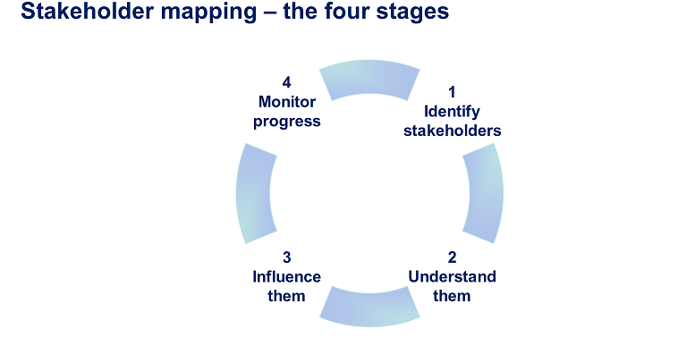
Creating a Stakeholder map is a visual way of showing how your stakeholders are classified in relation to their power and interest in what you are doing.

It will help you to clarify who the key stakeholders are and those that need less attention (resources).

The vertical dimension shows how much power they wield and the horizontal how much interest they have.

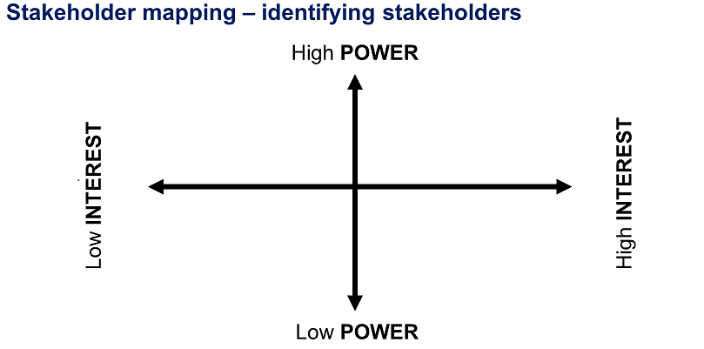
Group task:
- Individually make a list of the key stakeholders (internal and external) that are involved in or linked to the delivery of library services (5 minutes) This might also include ‘would be’ stakeholders that you have not yet built relationships with, but will be important for the success of a specific element of the transformation programme.
- Discuss your list with others in the group – identify an agreed list of the key stakeholders (10 minutes)
- As a group, agree the stakeholders’ level of interest, as well as the power they wield (15 minutes)

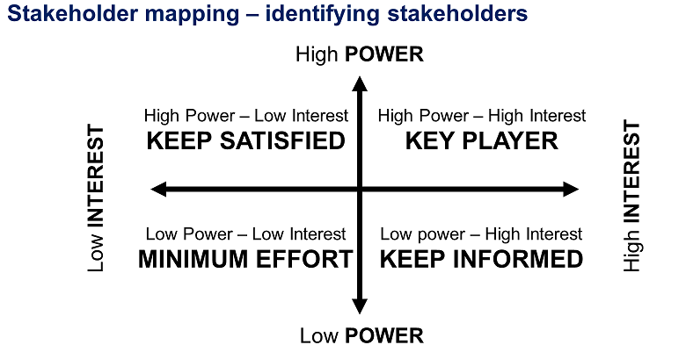

Using this approach will help you to target your available resources to the greatest effect.
- Those stakeholders with High Power and High Interest need to be given the most attention. You will need to engage closely with them and actively influence.
- It is also advantageous to keep those with Low Power but High Interest well informed, as this will help to ensure that you maintain good relationships with those stakeholders to whom what you are doing matters.
- Low Interest and High Power - there’s a need to put some effort into ensuring that they are updated.
- Low Power and Low Interest – there’s less imperative to spend a lot of time and resources engaging with this group, it will suffice to monitor views in case any move to High Interest.
Of course circumstances are dynamic and often complex, so during the progress of a key campaign you may need to revisit your analysis and check it against the changing picture.

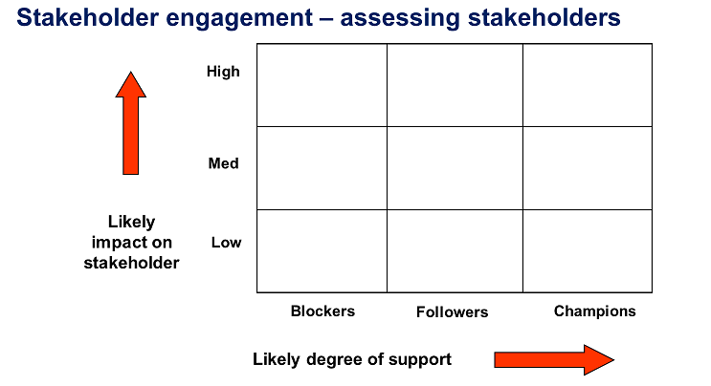

The more you know about each stakeholder the better chance you will have of building a relationship with them.

So having created a comprehensive map of stakeholders, you can then categorise the different individuals and groups, which will help you to tailor your approach.
First consider whether the impact of your plans is likely to be Low, Medium or High.
Then think about the degree of support they are likely to exhibit.

It’s important to understand the Blockers reasons; they may feel they will lose out in some way. Is this loss perceived or real? You will need to seek their views and try to counter their reasons with facts and data that could help to overcome their concerns. Proactive personal communication can work well here.

The Followers are inclined to go with the flow. But you will need to keep them informed and highlight the positive benefits of your plans.

The Champions help to drive the change and act in advocacy on your behalf. So actively communicate with them, keep them involved seeking their input where possible. You can draw on this group to promote the benefits of your plans.

Group task:
- Complete the exercise above to assess the stakeholders that you previously identified.
- Discuss how you can better understand the position and interests of your stakeholders.

Stakeholder engagement – understanding stakeholders
Once you’ve mapped and assessed your stakeholders, it’s time to think about what this means for your team, your organisation and other important relationships.
Questions that can help you understand the position and interests of your stakeholders are:
- What financial or emotional interest do they have in your work/plans? Is it positive or negative?
- What motivates them?
- What information do they want from you?
- What is their current opinion of your work/plans? Is it based on good information?
- Who influences their opinions generally and who influences their opinion of you?
- Do some of these influencers become stakeholders in their own right?
- If they are in opposition, what might win their support?
- If they aren’t likely to be won over, how will you manage their opposition?
- Who else might they influence if they remain in opposition?
What are the key questions for you to explore?

Influencing and engaging stakeholders
From mapping your stakeholders, you can decide what type of an engagement approach is required. This can be informed by categorising the type of relationship you need to have with each stakeholder, and how you want them to feel about elements of the transformation programme as a result.

Consulting | Co-creating
Based on pre-determined proposals Inviting feedback  Using a variety of channels for dialogue  Stakeholder feels involved | Open agenda discussions  Workshops and planning meetings  Generating and debating ideas using a  variety of platforms  Stakeholder feels ownership
Informing | Influencing
One-way communication  Providing news, information and updates  Delivered as and when necessary  Stakeholder is aware | Marketing approach  Encouraging behaviour change  Selling and telling  More tailored communication  Stakeholder buy-in secured

Stakeholder engagement - some considerations
Some organisations/individuals don’t want to engage – find other ways of keeping them on side.

Who is it best to engage with - everyone in the community or a targeted group?

What are the risks of not engaging with some people?

The suitability of the stakeholder engagement technique.

The ease and cost justification of engaging with the individual, group or organisation concerned.

Summary points:
- Buy-in from key stakeholders may be essential for the success of a transformation initiative
- Supporters can act as powerful champions – so identifying who these are amongst the stakeholder groupings early in the process is vital
- Building consensus increases the prospects of success
- Resistance, fear and lack of understanding can obstruct change – seek to counter with facts and data that could help to overcome concerns
- Prepare for how you are going to handle potential conflict well in advance.

Appendix 4. Suggested framework for meeting with internal service heads and commissioners/potential external partners

Below is a guide to the conversation with people that you don’t yet have a relationship with. This not a definitive list of questions, so allow the conversation to open up in the early stages to encourage the other person to talk. Always ask for an explanation where you don’t understand the jargon or acronym.

Introductions
Background to why you are here – explain. Seek to understand their perspective and approach, how they operate/do business, the opportunities for libraries to make a better contribution to what they are trying to do and some of the current barriers which are getting in the way of this happening.
Name:
Position:
Organisation:
How long in post:

Key priorities of their role
Q1. In general terms, what are the main priority outcomes and key challenges in the area and for the services you provide? (very broad opener)

Follow-up question: Do you use any particular models or tools for measuring outcomes or collecting evidence of impact?
(Note: It’s useful to know this at an early stage as any collaboration developed may involve libraries aligning with and adopting these measures i.e. Public Health Outcomes Framework/Adult Social Care Outcomes, The Warwick-Edinburgh Mental Well-Being Scale, Outcomes Star, Social Return on Investment)
Q2: When commissioning services/developing new partnerships, what are the key principles of how you approach commissioning or any specific approaches/key documents/current themes

Possible prompts:
- Guiding documents – national/local
- Published commissioning intentions?
- Community/user involvement – any user forums?

Q3: Can you tell me about any past or existing commissioning or projects that have involved library services? How did this come about?

Possible prompts:
- Any practical examples
- Note: you might draw a blank – don’t be deterred!

Q4: What are the opportunities and barriers for libraries to support your priority outcomes moving forwards?
Opportunities:
Barriers:
Having listened to the commissioner/potential partner, it may now be appropriate to discuss in more detail how libraries might contribute. If there is a clear outcome area where an element of the transformation programme can contribute, agree how this might be taken forward and what information they would like to receive from you.
Alternatively ask….
Q5: Would you be willing to work with us further when we have digested your information and advice?

Reflecting on the meeting
Capturing the perspectives from these meetings is especially valuable, so that you can use the notes with your team to:
- Review and consider the wider needs of the community you work in
- Learn about other services, their priorities, language, guiding documents and aspirations
- Do further research and reading where necessary to grow your understanding
- Consider what the realistic opportunities and potential barriers are for library partnerships locally.

Key points to consider in making a follow up response include:
- Present yourself and the library service as a strategic and creative partner.
- Articulate the library offer in terms of outcomes and not just activities
- Present the libraries offer in a way that is relevant for each individual commissioner/potential partner – are they interested in universal services that support older people, targeted groups such as dementia sufferers or looking to signpost those with personal budgets to community support services.
- Communicate both the wellbeing benefits and cost benefits (it is particularly useful if you know the cost per unit for participating in a library activity, so this can be compared with other established interventions).

