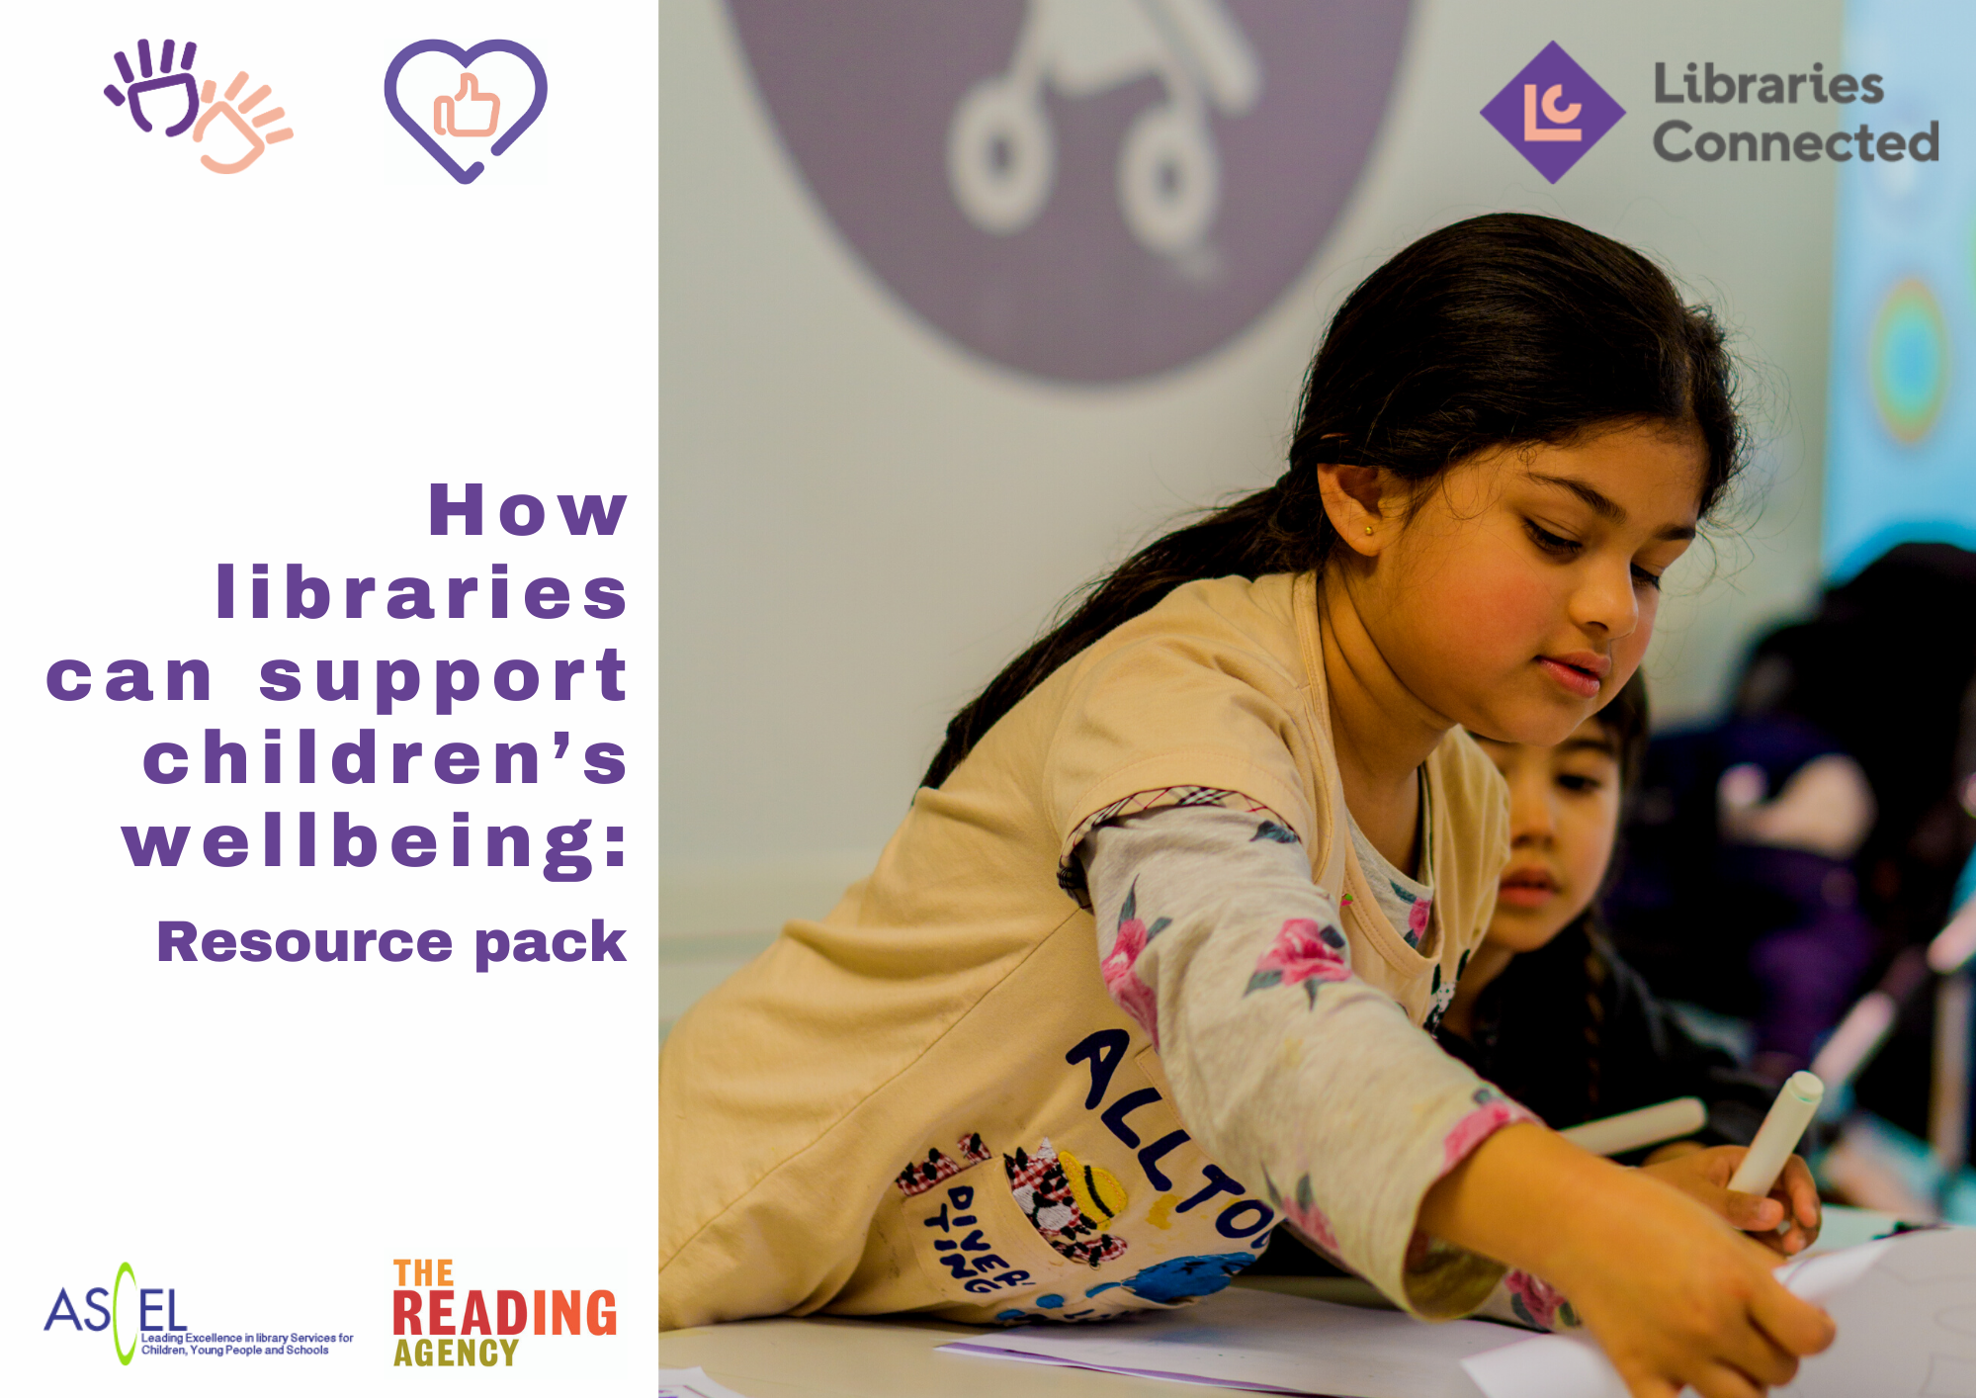
Introduction
Research is starting to uncover the toll the pandemic is taking on the lives of children and young people especially those in more vulnerable households. Improving children’s outcomes is going to depend on a concerted effort by all those who work and engage with children.
The offer to children and young people from public libraries as described in The Children’s Promise and expressed through the Universal Library Offers demonstrates how libraries can contribute to improving children’s wellbeing. In this pack we highlight specific areas where we believe library services can contribute to the recovery of children and their families.
We have included links to national support or resources and case studies. We hope you will use this pack to review how your own service is responding to the current needs of children, to inspire ideas for further action, to pro-actively build local partnerships with health, leisure, education to offer joined-up support to communities and as a source of advocacy materials to stakeholders and decision makers.
The pack was inspired by the discussion at the ‘Children, Wellbeing and Libraries’ webinar - a collaboration between The Reading Agency, ASCEL and Libraries Connected https://www.youtube.com/watch?v=oLdTME9Ydsc delivered as part of the Universal Health and Wellbeing Offer and the Children’s Promise.
We intend this document to be a living resource so if there are case studies or elements you wish to add, please email info@librariesconnected.org.uk
1. Context
Wellbeing challenge | Evidence
Increased anxiety and uncertainty in children and families | - More than a million parents believe their child could benefit from professional help in the wake of the coronavirus lockdown.  - Childline has delivered almost 7,000 counselling sessions with children about the impact of the coronavirus outbreak.  - Caring for children 24 hours a day has led to increased stress amongst many parents and siblings (Children’s Commission).
Gaps in learning especially disadvantaging vulnerable children | - Ofsted has reported that children hardest hit by COVID-19 pandemic are regressing in basic skills and learning.  - Teachers estimate pupils are on average three months behind (Children’s Commission)  - School closures and inequalities in home learning environments mean libraries can offer a vital additional learning environment.  - Only 5% of children most at need (known to social care services and with greater levels of SEN) attended school during the first lockdown (DfE).
The need for reading for escape, and connection and fulfilling children’s ‘insatiable desire for stories’ | - Many children don’t have access to books at home. Of children who report having fewer than 10 books in their homes, 42% say they do not like reading and only 32% say they are 'very confident' readers. For children who report having over 200 books at home, only 12% say they do not like reading and 73% consider themselves 'very confident' readers⁸  - Children who read books often at age 10 and more than once a week at age 16 gain higher results in maths, vocabulary and spelling tests at age 16 than those who read less regularly⁹  - During lockdown, nearly 1 in 4 (23.4%) children and young people said that they have listened to audiobooks more than before lockdown.
Children’s worlds have narrowed: | - Children keeping in touch with friends through social media, online games and video chat has been critical to maintaining friendships and distracting from worry about pandemic (Save the Children)  - But online contact is not as frequent or intensive as real-life interaction:  - Studies have found that reading for pleasure enhances empathy, understanding of the self, and the ability to understand one's own and others' identities²³
Developmental delays in speech, language communication and social and emotional skills in the early years | - The impacts observed by early years providers https://assets.publishing.service.gov.uk/government/uploads/system/uploads/attachment_data/file/933836/COVID-19_series_briefing_on_early_years_October_2020.pdf  - https://www.cdc.gov/coronavirus/2019-ncov/daily-life-coping/parental-resource-kit/early-childhood.html  - https://www.theguardian.com/lifeandstyle/2021/feb/10/its-the-isolation-parents-on-the-impact-of-lockdown-on-children

2. What libraries do to support children
Wellbeing challenge | What libraries do to support children | Resources available to libraries | Library Service Actions/plans
Increased anxiety and uncertainty in children and families | Libraries can offer resources and activities in a welcoming, kind and reassuring environment to support families.  - Provision of physical and digital (parenting collection) reading resources to support parents and help them understand how their child is feeling and how to discuss emotions  - Highlighting books to support children understand how they are feeling  - Libraries hosting and participating in partnership events supporting targeted vulnerable families/anxious children  - Libraries provide an engaging and safe digital offer for children and families to occupy and engage children at home in positive activities  - Libraries offer safe in-person activities when restrictions allow, providing opportunities for families to spend time together – either individual or group activities and events and considering working with partners to deliver outdoor events  - Connect parents in the local community in online discussion sessions about ways of coping and encourage using Reading Well resources  - Libraries commissioning artists and performers to deliver arts and cultural events that provide fun and escape and working through feelings  - Libraries use the autism friendly libraries guidance to ensure library spaces are as reassuring and as welcoming as possible for neuro-divergent children. | Book Collection - ideas to support children to stay safe, calm, connected and hopeful during the COVID-19 crisis.  Reading Well for children book collection developed with leading health professionals to support children and family wellbeing. (Download a Get Involved Guide for parents and carers)  Libraries from Home giving examples of some of the digital services available from public libraries: online events and activities, reading groups, audio, and e-book resources.  Libraries in Lockdown report shows how libraries kept communities connected and supported the most vulnerable.  Autism-Friendly Libraries  New Reading Friends projects – sharing early learning from family focused projects.
Gaps in learning especially disadvantaging vulnerable children | Libraries provide a vital third space between the school and home that offers children the opportunity to learn, develop and flourish.  - Libraries support parents signposting online home learning resources.  - Offer or continue to offer access to digital learning resources for homework help such as access to historical newspapers, language learning, encyclopaedias  - Providing online events with skilled homework tutors to help children find information for school and project work using books and the Internet  - Libraries and SLS’s connecting with local schools providing lessons plans or activities or virtual class visit to promote public libraries  - Libraries partners in loaning/gifting digital devices to families  - Libraries offering support for transitions between schools and starting school  - Promoting library events which give children a sense of positive personal achievement – such as SRC and ensuring these are recognised at school  - Digital support resources in libraries for children to use and provision of study spaces when restrictions allow  - Libraries provide reading resources to support children  - Providing learning events and activities in libraries when restrictions allow  - Pro-actively seeking internal partnerships with health, leisure, education to offer joined-up support to communities  - Libraries also actively working with partners to ensure children are healthy and ready to learn such as:  - Supporting local food poverty campaigns/holiday hunger schemes/period poverty  - Making resources available to children so they can participate in activities with peers – e.g., Lets Create bags  - Outreach partnerships to engage with families and promote library facilities and build confidence to revisit libraries. | Libraries from Home giving examples of some of the digital services available from public libraries: online events and activities, reading groups, audio, and e-book resources.  ASCEL’s report ‘Children’s Library Journeys’ describes how the public library supports children at different stages of childhood  Virtual School Library is a free platform for primary schools, offering pupils access to free books and activities from popular children's authors  Words for Life created by the National Literacy Trust, provides parents, children and young people with activities and support to improve language, literacy and communication  BBC programming for children missing school: 9-12am on CBBC for primary school pupils and 1-3pm on BBC2 for secondary pupils (catch up on iplayer)  The Film Space: free moving image, curriculum linked teaching resources.
The need for reading for escape, and connection and fulfilling children’s ‘insatiable desire for stories’ | - Libraries promote reading for children across all the significant library calendar spikes  - Promote activities physically and virtually like the Summer Reading Challenge and the Winter Mini Challenge  - Use social media actively to promote children’s books and make video book reviews etc ensuring a diverse range of books are promoted including the e-lending offer  - When possible make safe spaces where children and parents can comfortably share stories  - Promote online storytimes and rhymetimes  - Programme creative physical and digital book events activities in libraries, including author and illustrator events  - Promote book awards  - Engage children in reading related competitions and creative events. | https://www.librariesconnected.org.uk/resource/universal-library-offers-calendar-2021  Libraries Connected work to relax UK children’s publishers’ permissions for online storytimes - see publisher restrictions spreadsheet  CILIP’s National Shelf Service Initiative YouTube book recommendations for children and families from professional librarians  Chatterbooks resources page: reading activity packs and digital resources from UK's largest network of children's reading groups  How to run a virtual reading group with children’s guidelines  The Reading Agency’s monthly booklists for children and young people  The Reading Agency hub - access ideas, activities and challenges from across our programmes to entertain and educate  EmpathyLab has toolkits, resources and a book collection for building children’s empathy through high-quality reading.  Children’s Poetry Archive listen to poems read out loud, for all age groups.  Teacher’s Reading Challenge and book sorter tool, which recommends a book that children have enjoyed
Children’s world has narrowed | Children and families have access to their wider community and a sense of belonging via their library service.  - Libraries offer cultural events online and digital events and activities that broaden children’s experience of the world and allow safe contact with others – e.g. Minecraft groups, escape rooms  - Libraries commissioning story event and cultural events aimed at expanding horizons, focusing on different cultures, traditions, histories etc.  - Libraries offering outdoor activities when weather and restrictions allow to reconnect children with community spaces  - Encourage families to go on Empathy Walks around their community and connect them back to stories (Empathy Walks will be available in Empathy Day 2021 / Family pack resources from May 2021)  - Highlight annual calendar events that mark or celebrate awareness events like Empathy Day and Anti-Racism day, refugee week – days that widen understanding and engage children and young people in reflection and debate in a safe space  - Libraries use creative digital and physical displays to showcase the books that widen horizons and reflect the diversity of the community  - Offer takeover activities where groups of children and young people takeover libraries’ social media digital offers  - Connecting with local schools offer small scale school visits or virtual class visits – connecting children as well with speakers with different experiences in local communities. | Fun Palaces share practical suggestions to connect more in your local community or pass time creatively in self-isolation.  Toolkit for hosting online events  Toolkit for keeping children safe online  ASCEL. Children & Young People's Library Events - YouTube
Developmental delays in speech/language and communication and social and emotional skills in the early years | - Libraries delivering regular online rhyme times and offering physical rhyme times as soon as can be done safely,  - Libraries creating local partnerships e.g., with speech and language therapists inviting them to visit rhyme times and give parents support,  - Work with partners in Health and Education and through other pathways to give Bookstart packs to parents. Are libraries catching up with families who have missed receiving their packs. Develop social media campaign ‘Have you had your Bookstart pack?’  - Libraries promoting and using the resources of Tiny Happy People or Hungry Little Minds to encourage parents to talk with young children.  - In rhyme time rhymes that encourage lots of speech and communication – lots of joining in, etc.  - Share early stories that demonstrate social and emotional skills.  - Use rhyme times to help children become aware of other children promote sharing and turn-taking games (if safe to do so) and celebrate the families who come – singing welcome songs naming each child, celebrating birthdays, etc.  - Run Early years play sessions such as Duplo clubs as soon as it is safe again to share equipment. | Use ASCEL’s rhyme time toolkit for reviewing quality of rhyme times.  https://ascel.org.uk/rhyme-time-and-seven-quality-principles-toolkit  https://www.bookstart.org.uk  https://www.bbc.co.uk/tiny-happy-people  https://hungrylittleminds.campaign.gov.uk/  ASCEL will develop national early years messages for libraries to use, targeting:  - People who have had babies since the start of lockdown  - People who need to collect Bookstart packs  - The importance of parents sharing stories and rhymes to support children’s speech and language skills  - Celebrating rhyme times when they physically return to libraries.
Signposting for support | Library services offer a curated collection of relevant signposting for children and families to ensure they are aware of and engaged with services to support them.  - Develop guidelines for information clearly visible in libraries and on library websites  - Create a local stakeholder map of signposting services. | Signposting parents and carers to the Every Mind Matters mind plan and support tool for national signposting  The Reading Agency Library Staff Social Prescribing Toolkit  National Academy of Social Prescribing: Checklist of national organisations and ‘types’ of local organisations for social prescribing.

Issue 1: April 2021

